Q1: A product team at a Pakistani bank has been running their mobile banking app for 3 years. Usage data shows that 60% of users drop off during the fund transfer process. The team wants to redesign the transfer flow.
The project manager says: "We already know what the problem is, the steps are too many. Let's just redesign it."
- Should the team conduct a user needs assessment before redesigning? Justify your answer in 1 to 2 sentences. [1]
- What specific question would a needs assessment help answer that the usage data cannot? [1]
Q2: A UX researcher is designing an interview protocol to understand how students at a Pakistani university manage their academic workload. She writes the following core questions:
- "Do you find it hard to manage assignments?"
- "What is your favorite app for studying?"
- "Tell me about the last time you missed a deadline, what happened?"
- "Why don't students use the library more often?"
(a) Two of these questions are problematic. Identify them. [1]
(b) Rewrite one of the problematic questions to make it a strong interview question. [1]

Q3: Look at the checkout screen below. A user is trying to complete a purchase on Daraz for the first time.
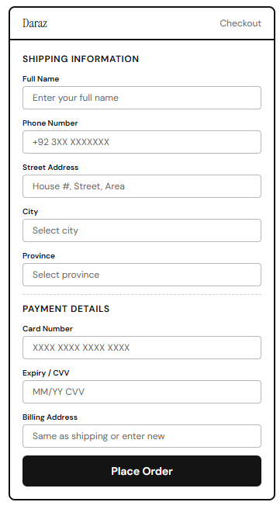
(a) Identify one working memory violation on this screen and explain why it creates a problem for the user. [1]
(b) Mention one element on this screen that relies on recall rather than recognition. Suggest a redesign that shifts it to recognition. [2]

